Word Equations  outcome = explanatory + other stuff  Y = X + other stuff | Summary Tables  # compute five-number summary  favstats(~ Y, data = data_set)  # create frequency table  tally(data_set$Y)  tally(~ Y, data = data_set)  # tally by condition  tally(~ Y < 1900, data = data_set)  # two-way frequency table  tally(Y ~ X, data = data_set, margin = TRUE, format = “proportion”) |  | Simple Statistics  mean(data_set$Y)  var(data_set$Y)  sd(data_set$Y)  cohensD(Y ~ X, data = data_set)  cor(Y ~ X, data = data_set)  b1(Y ~ X, data = data_set)  b1(model_name)  pre(Y ~ X, data = data_set)  f(Y ~ X, data = data_set)

Basics
print("Hello world!")

# assign value to object
my_number <- 5
# combine values into vector
my_vector <- c(1, 2, 3)
# first element in vector
my_vector[1]
# orders values or cases
sort(my_vector)

# arithmetic operations
sum(1, 2, 100), +, -, *, /
sqrt(157)
abs(data_set$Y)
# logical operations
>, <, >=, <=, ==, !=, |, &

# results in a variable with values
# of TRUE or FALSE

data_set$C <- data_set$A > data_set$B
 | Probability Distribution  # calculate the probability area  xpnorm(65.1, mean = 60.1, sd = 8.7)  zscore(data_set$Y) |  | Simulation  # sample without replacement  sample(data_set, 6)  # sample with replacement  resample(data_set, 10)  # shuffle the outcome in a graph  gf_point(shuffle(Y) ~ X, data = data_set)
Data Frame  # structure of data frame  str(data_set)  # view first/last six rows  head(data_set)  tail(data_set)  # select multiple variables select(data_set, Y1, Y2)  # first six rows of selected variables  head(select(data_set, Y1, Y2))  # select variable (a column)  data_set$Y  # find rows that meet condition  data_set[data_set$Y > 40]  filter(data_set, Y > 300)  filter(data_set, is.na(Y) == FALSE) | # arrange rows by variable  arrange(data_set, Y)  # creates data frame from csv file  data_set <- read.csv("file_name", header = TRUE)  # convert quantitative variable to categorical  factor(data_set$Y)  factor(data_set$Y, levels = c(1,2), labels = c("A", "B"))  # transform values  recode(data_set$Y, "0" = 0, "1" = 50, "2" = 100)  # creates two equal sized groups  ntile(data_set$Y, 2)  # convert categorical variable to quantitative  as.numeric(data_set$Y)  # create new variable inside a data frame  data_set$new_var_name <- #code/calculations  # Ex: create variable `C` by adding `A` and `B`  data_set$C <- data_set$A + data_set$B |  | Fitting & Evaluating Models  # empty model  empty_model <- lm(Y ~ NULL, data = data_set)  # use one expanatory variable  model_name <- lm(Y ~ X, data = data_set)  # model predictions and residuals  data_set$empty_predict <- predict(empty_model)  data_set$empty_resid <- resid(empty_model)  # produce ANOVA table  supernova(model_name)
Visualizations  gf_histogram(~ Y, data = data_set) %>%  # change labels  gf_labs(title = "Graph Title",  x = "Y_Name", y = "Frequency")  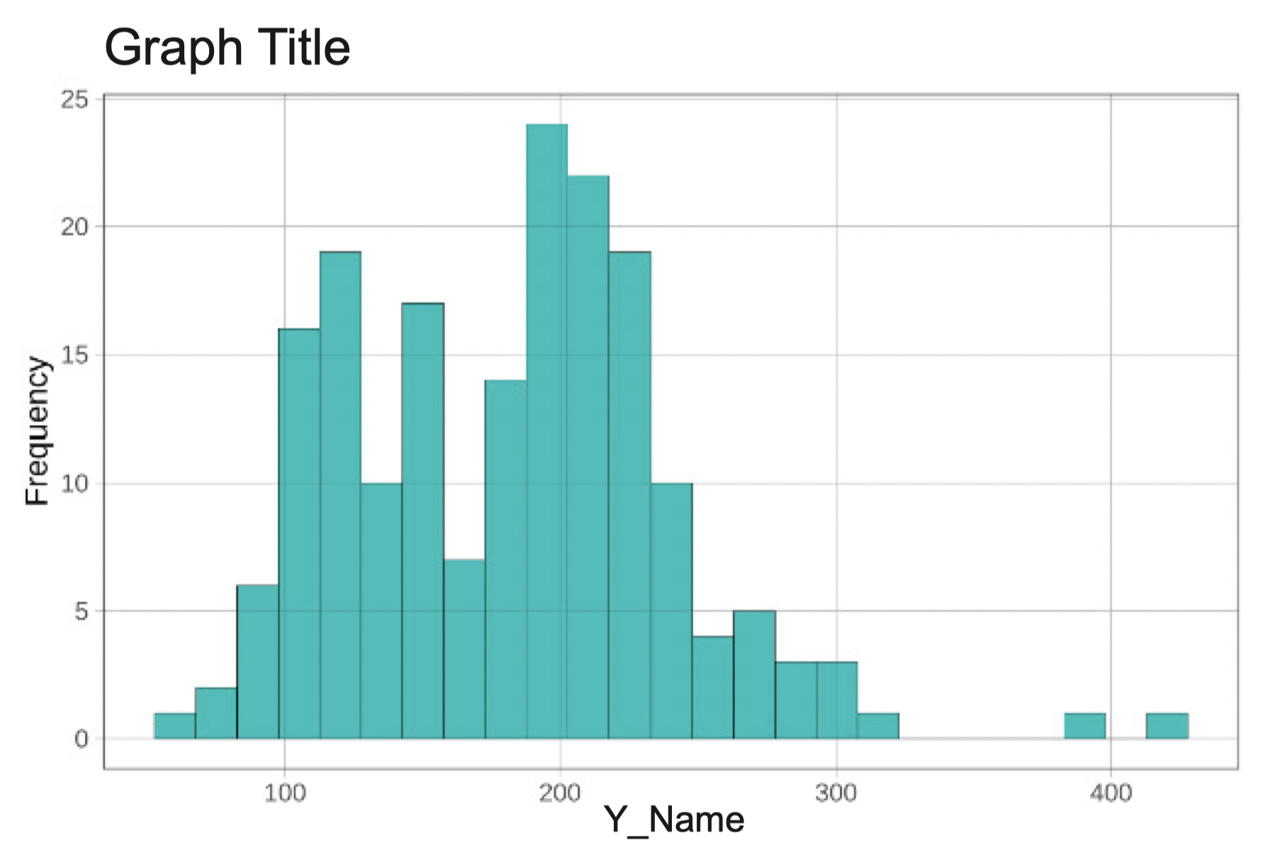  gf_dhistogram(~ Y, data = data_set, fill = "orange") %>%  gf_density()  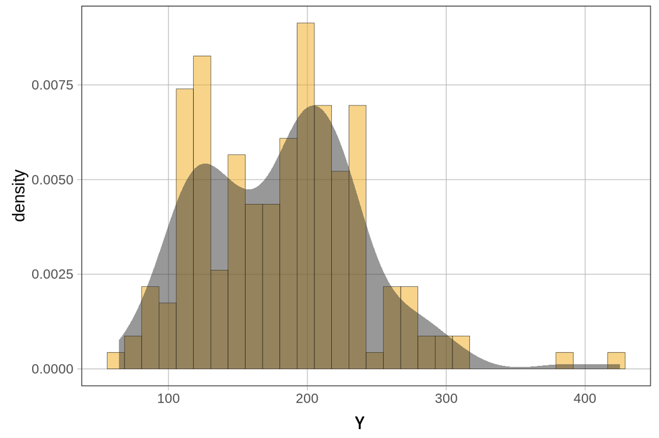  # faceted grid of histograms  gf_histogram(~ Y, data = data_set) %>%  gf_facet_grid(X ~ .)  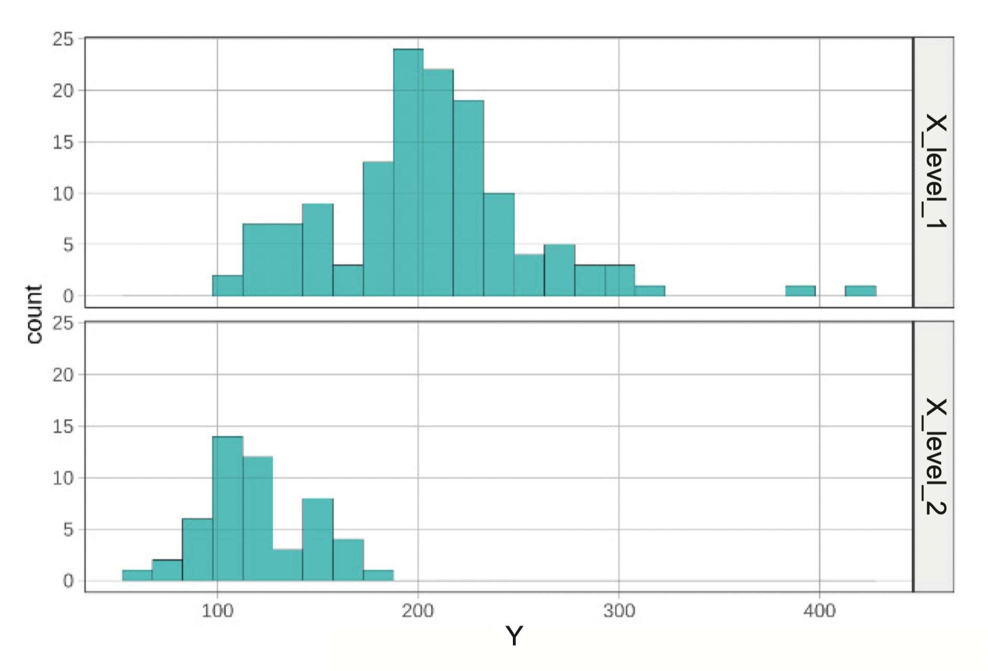 |  | gf_point(Y ~ X, data = data_set)  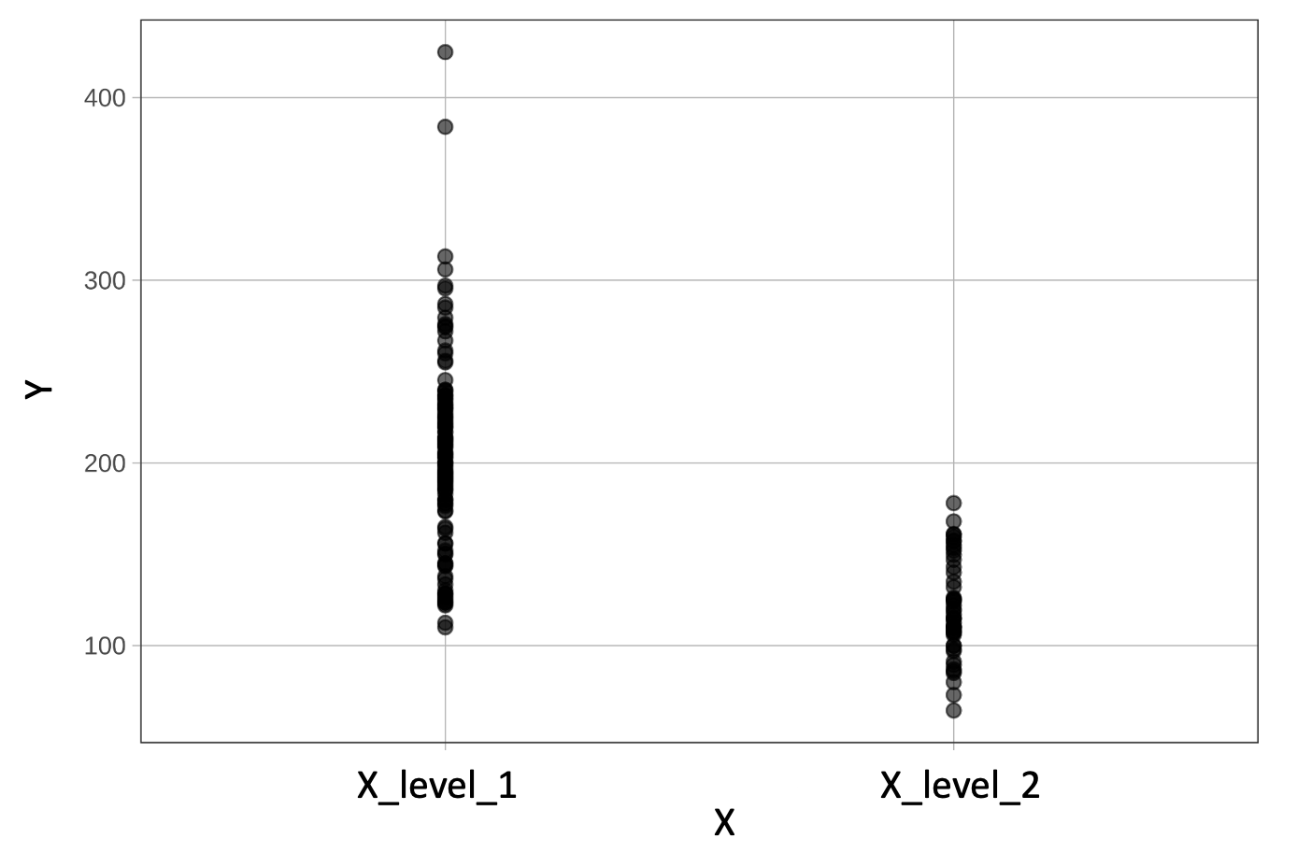  gf_jitter(Y ~ X, data = data_set)  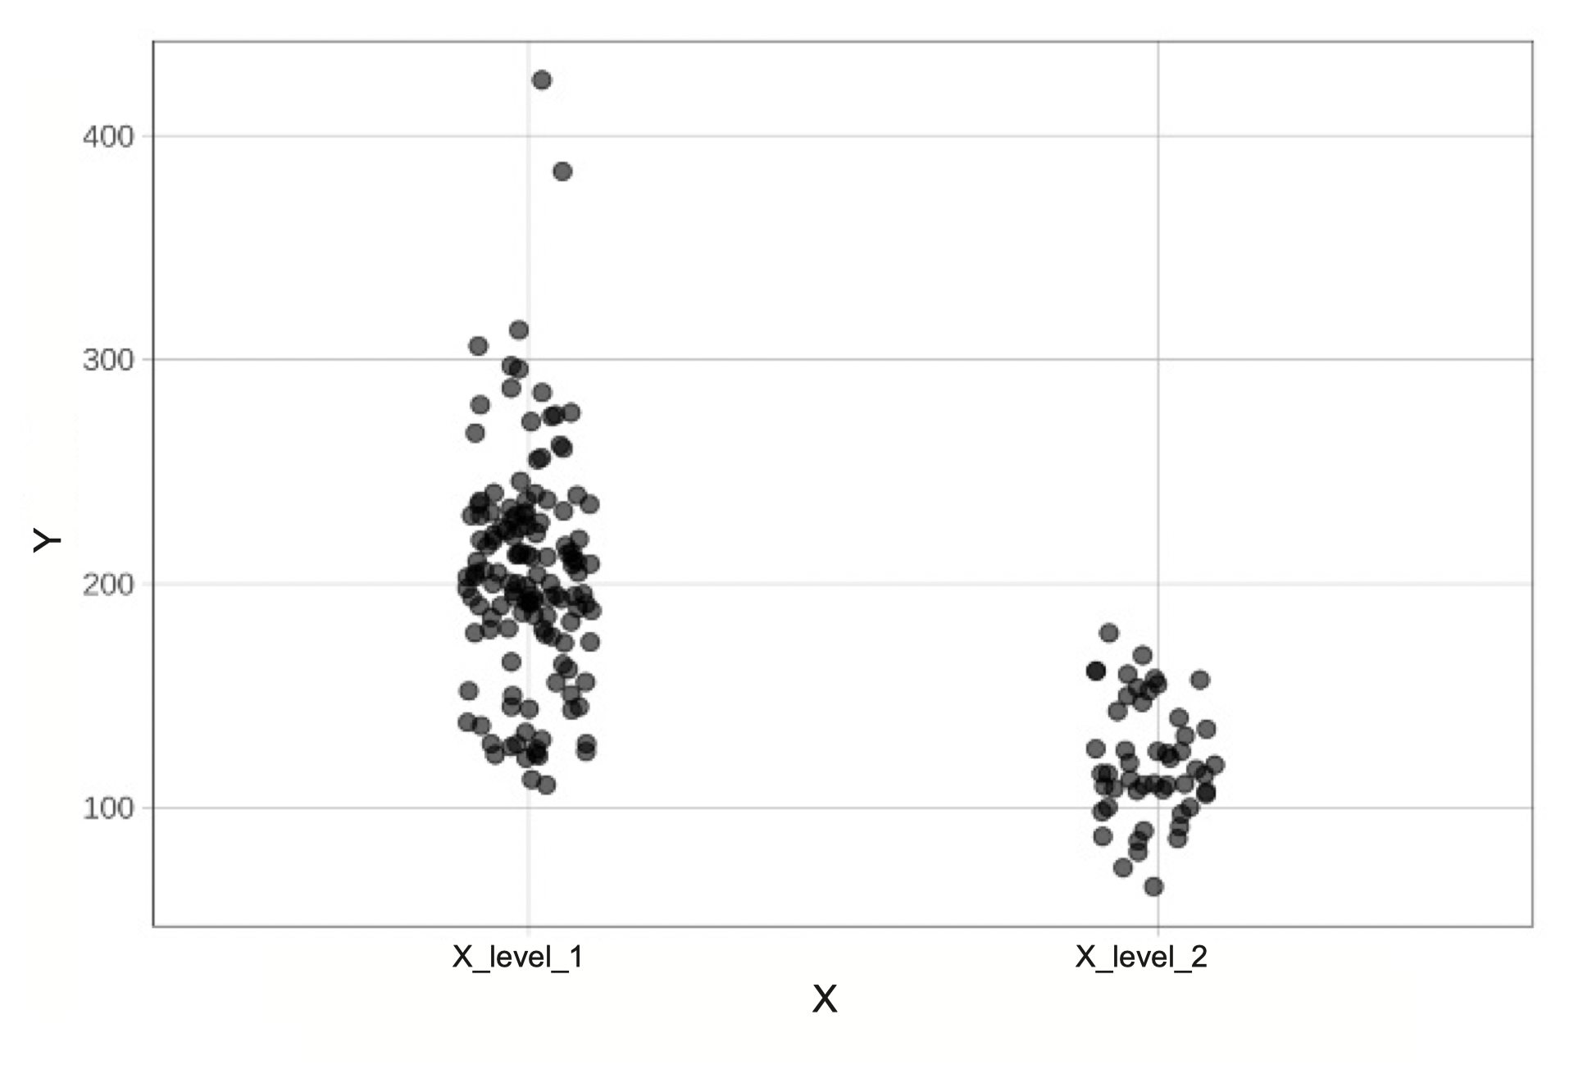  gf_boxplot(Y ~ X, data = data_set)  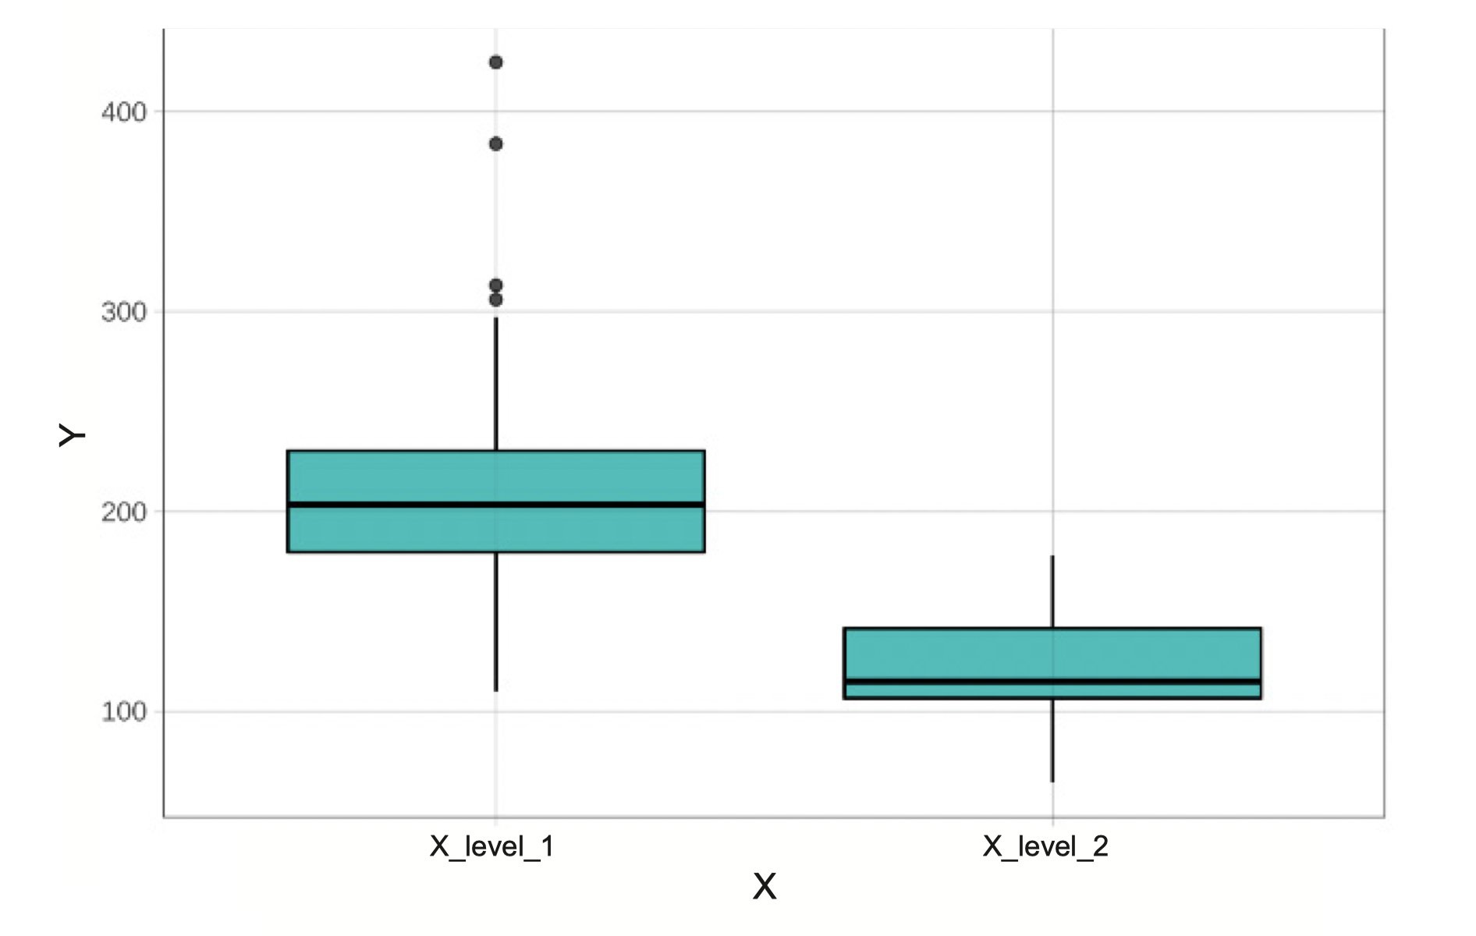 |  | gf_boxplot(Y ~ X, data = data_set, fill = "orange") %>%  gf_jitter(height = 0, alpha = .2, size = 3)  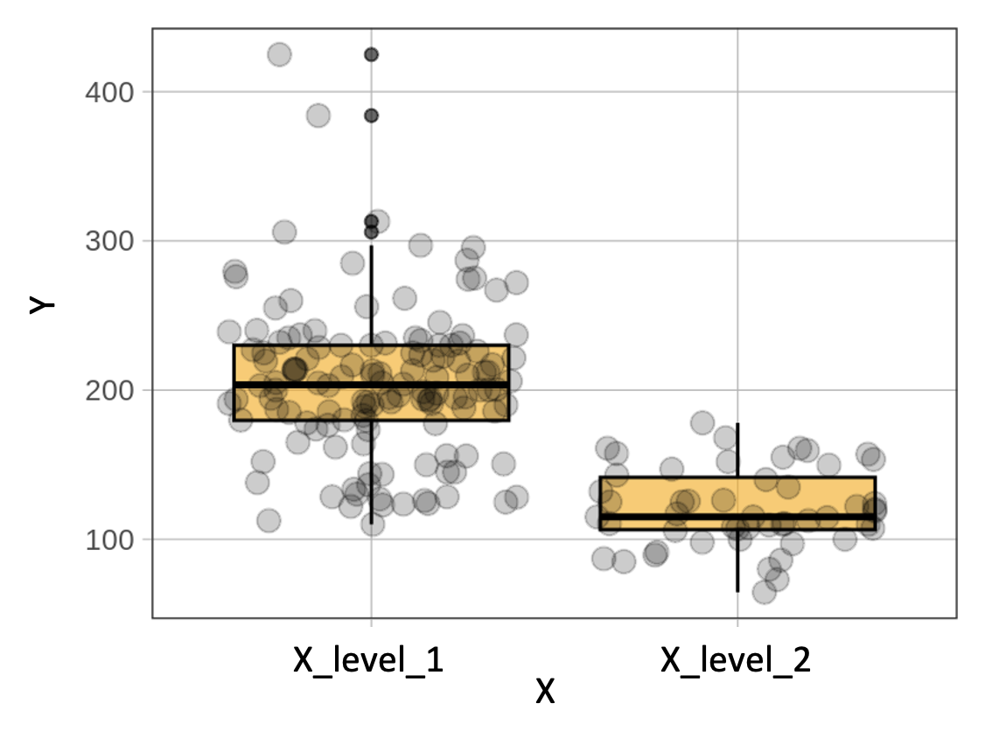  gf_bar( ~ Y, data = data_set)  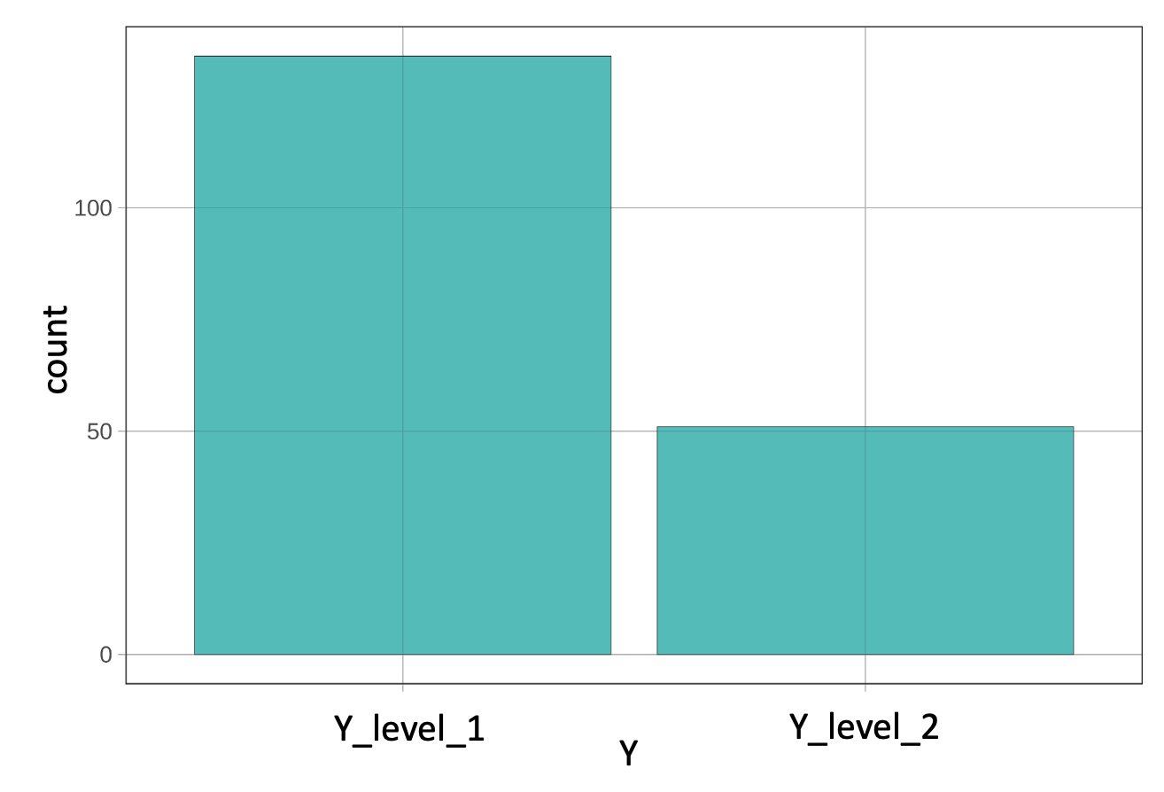  gf_point(Y ~ X, data = data_set) %>%  # add model predictions as red points  gf_point(Y ~ X , shape = 1, size = 3,  color = "firebrick") %>%  # add best fitting model as a red line  gf_model(model_name, color = "red")  